1. Aim
To study the Zoho Creator platform by creating a sample application and understanding its components such as forms, reports, dashboards, and the application architecture (Develop, Deploy, and Manage).

2. Setting up Zoho Creator

I. Create the Sample Application

Steps
- Sign in to your Zoho Creator account.
- Click Create New Application.
- Select Create from Scratch or use the Demo App available during signup.
- Enter the application name Student Management System.
- Click Create.
- Add a Form to collect student details.
- Zoho Creator automatically generates a Report to display submitted records.
- Create a Dashboard to visualize the stored data.
- Save and run the application.
Sample Application Created:
- Application Name: Student Management System

II. Screenshots

A. Creating Form
Description:
The form is used to collect user information. It contains the following fields:
- Name
- Phone Number
- Address
- Email
When the user clicks Submit, the data is stored in the application database.

B. Creating Report
Description:
The report displays all submitted records in a tabular format. It allows users to:
- View records
- Search records
- Sort data
- Edit records
- Delete records
The report is automatically linked to the form.
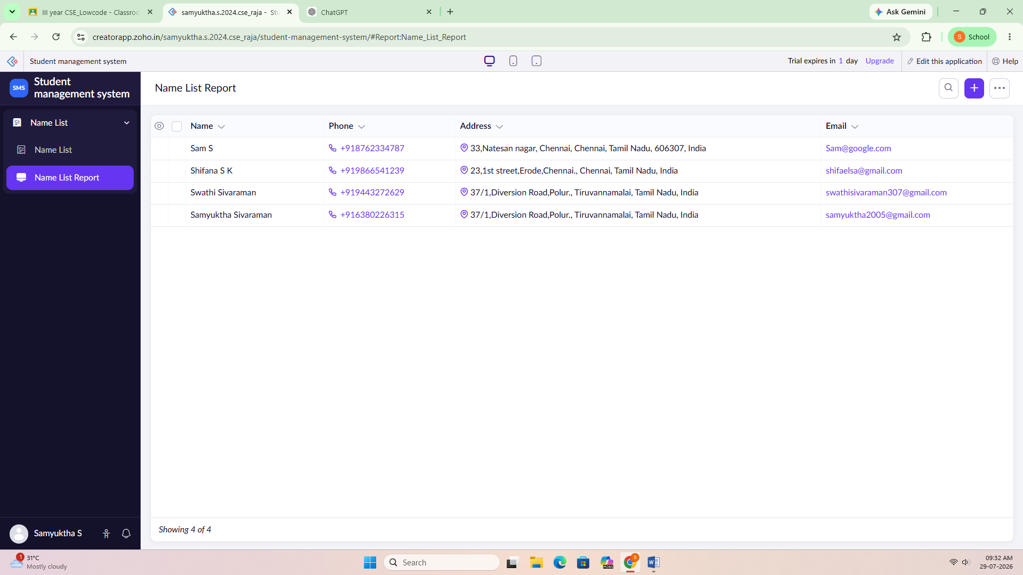

C. Creating Dashboard
Description:
The dashboard presents data using different visualization components such as:
- Charts
- Number Cards
- Reports
- KPIs
- Widgets
It helps users analyze information quickly.
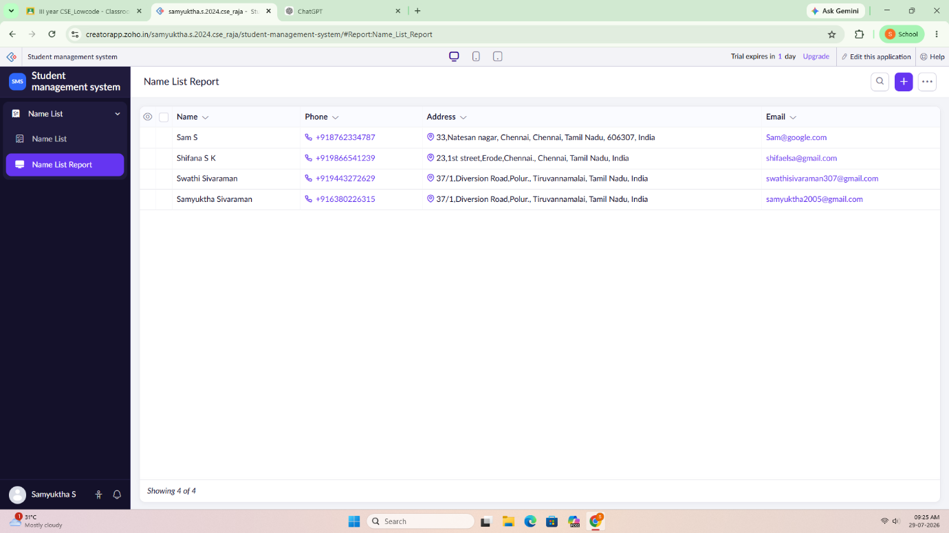

3. Exploring the Zoho Creator Platform Architecture and Interface
Zoho Creator mainly consists of three major components:

A. Develop

Definition
The Develop section is where applications are designed and built. It provides tools to create forms, reports, pages, workflows, and integrations without requiring extensive programming knowledge.

Components

Application
A collection of forms, reports, pages, workflows, and settings that work together to perform a specific business process.

Form
A form is used to collect information from users. Every submitted form creates a record in the database.
Example:
Student Registration Form

Fields
Fields are individual input elements inside a form.
Examples:
- Single Line
- Number
- Email
- Phone
- Address
- Date
- Dropdown
- Lookup
- File Upload

Report
A report displays the stored data from forms.
Types include:
- List Report
- Calendar Report
- Kanban Report
- Spreadsheet Report
- Pivot Report
Reports allow users to search, filter, edit, and delete records.

Page
A page is a customizable interface that combines reports, forms, buttons, charts, and HTML components into one screen.

Workflow
A workflow automates actions when certain conditions are met.
Examples:
- Send Email
- Update Record
- Display Alert
- Execute Deluge Script

Functions (Deluge)
Deluge is Zoho Creator's scripting language used to perform advanced logic and automation.
Examples:
- Validate input
- Calculate values
- Connect with external APIs
- Automate business processes

B. Deploy

Definition
The Deploy section is used to publish and share the application with users.

Components

User Permissions
Controls who can:
- View data
- Add records
- Edit records
- Delete records

Roles
Roles define the level of access for different users.
Examples:
- Administrator
- Staff
- Student
- Manager

Sharing
Applications can be shared with:
- Individual users
- Teams
- Organizations
- Public users (if enabled)

Mobile Access
Zoho Creator applications can be deployed on Android and iOS devices using the Zoho Creator mobile app.

Custom Domain
Organizations can publish applications using their own domain name for branding purposes.

C. Manage

Definition
The Manage section is responsible for maintaining and monitoring the application after deployment.

Components

Users
Manage all users who have access to the application.

Permissions
Modify user access rights and security settings.

Version Management
Keeps track of application updates and allows developers to maintain different versions.

Backup and Restore
Allows application data to be backed up and restored when needed.

Audit Logs
Maintains records of user activities, including:
- Login history
- Record updates
- Application changes

Integrations
Connects Zoho Creator with other services such as:
- Zoho CRM
- Zoho Books
- Google Drive
- Microsoft 365
- REST APIs

Notifications
Automatically informs users through:
- Email
- SMS
- Push Notifications

Advantages of Zoho Creator
- Low-code application development.
- Drag-and-drop interface.
- Built-in database management.
- Workflow automation.
- Mobile-friendly applications.
- Easy integration with other Zoho products.
- Secure user management.
- Quick deployment and maintenance.

Result
A sample Student Management System application was successfully created in Zoho Creator. Forms were used to collect data, reports were generated to display records, and the platform architecture (Develop, Deploy, and Manage) was explored along with the definitions of its major components.

